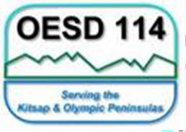
Olympic Educational Service District 114
Early Learning Department

DECA Outcomes Reflection Tool

Classroom: Click or tap here to enter text. Rating Period:Click or tap here to enter text. Date: Click or tap to enter a date.
 | Class Profile Report | Individual Child Report
Report Review:  (What does the data tell me?) | Click or tap here to enter text. | Click or tap here to enter text.
Adjustments to Practice:  (What and how I need to plan to support the report data. List targeted strategies to be included on upcoming lesson plans.) | Click or tap here to enter text. | Click or tap here to enter text.
Reflection of Practice: (Halfway through rating period, reflect on how adjustments are affecting social emotional skill development. Document any  additional needed shifts or progress toward goals. | Click or tap here to enter text. | Click or tap here to enter text.

Date Reviewed: Click or tap to enter a date. Coach Signature (virtually typed): Click or tap here to enter text.

