RECRUITMENT
Performance Standards
EHS-CB  EHS-HB  HS  1302.13 | ECEAP  PAO-37

R-1. Recruitment of Priority Populations
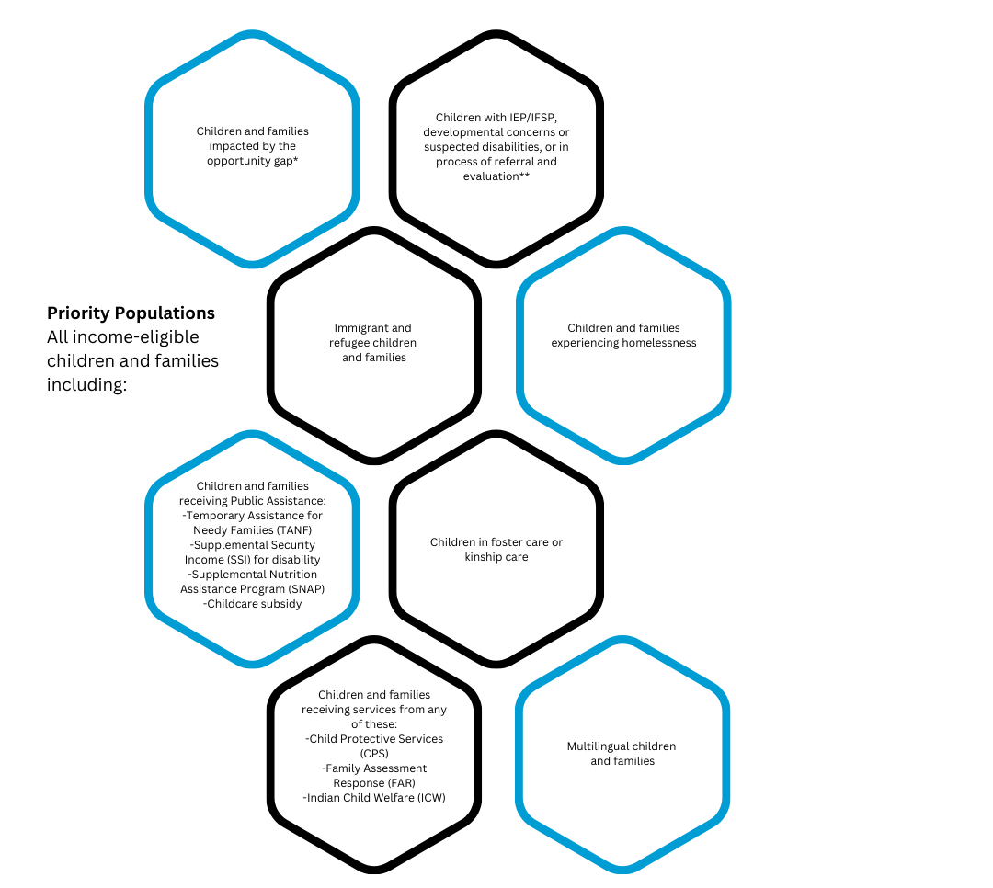
Conduct intentional recruitment throughout the program year and focus your recruitment efforts on families in these priority populations:

*OESD 114 aims to serve children and families who find themselves affected by the opportunity gap. Closely related to achievement gap and learning gap, the term opportunity gap refers to the ways in which race, ethnicity, socioeconomic status, English proficiency, community wealth, familial situations, or other factors contribute to or perpetuate lower educational aspirations, achievement, and attainment for historically marginalized children.
**Head Start requires that 10% of all enrolled children are to be served under IDEA with an Individualized Education Plan (IEP) or an Individualized Family Service Plan (IFSP). Meeting this requirement is a coordinated effort between recruitment and enrollment practices and identifying children eligible for services throughout the program year. Recruitment efforts are conducted to reach children with IEPS/IFSPs, with referrals for evaluations, and with developmental concerns or suspected disabilities.

Eligibility and enrollment are not automatic or guaranteed based on Priority Population only. Each child’s eligibility determination is verified in writing using all ERSEA steps, and each child is prioritized before selecting.

R-2. Recruitment Plan
Strong recruitment efforts and plans generate more applications than funded slots. This creates an active and up-to-date waitlist. Our recruitment plans are a systematic way to collaborate and partner with other staff and the community to get the word out about our Early Learning program. We ensure that all staff, regardless of their role in the program, are informed and have a basic understanding of all areas of ERSEA and can articulate the program’s process for recruitment.

R-3. Recruitment Tools
Use these recruitment tools to strategically and creatively ensure that all families in our community can apply for our Early Learning program:

1. Program Parents/Guardians: Enrolled and previously enrolled families are key recruitment resources. Families can share Early Learning opportunities with family and friends and where or how they found out about our Early Learning program with the community. Recruitment strategies and suggestions for improvement can be discussed at family meetings and at family engagement events.

2. Early Learning Staff: All program staff are expected to contribute to our recruitment efforts. This may include, but not limited to, professional networking or sharing community events with each other.
3. Community Partners: These partnerships will help gather information about resources and opportunities that are available to families. Building partnerships with ESIT, Birth-to-3 agencies, Part C providers, and K-12 Special Services (Part B) including ChildFind programs will support efforts to meet the minimum 10% disability requirement for HS/EHS.
4. Multilingual Services: Use of multilingual flyers and interpreters to reach out to multilingual children and families. You may want to share Speak Your Language with families, a website about the benefits of being bilingual.
5. Flyers and Other Print Materials: You may use the recruitment flyers provided by OESD 114. These flyers include a QR code families can use to access information about OESD QR Code Page.

6. OESD 114 Early Learning Website: Provide families with a place to learn about OESD programs and to find an option that fits their child’s needs.
7. Social Media: Department will work to create a social media policy.

R-4. Summer Recruitment Hours
OESD may offer additional funds for staff to use towards summer recruitment and enrollment. This opportunity is dependent on available funds and staff will be notified in the Spring of each year of summer recruitment options.

