**First Day of Service for Children in ELMS**

1. Click on “Child” Tab

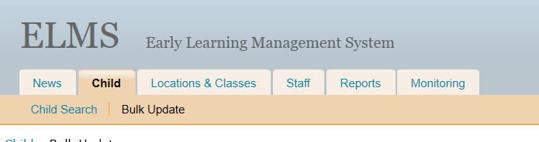

1. Click on “Bulk Update”
2. Find the child you want to enter start date for
3. Select the date for “Actual Start Date”

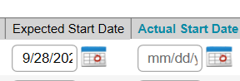

1. Click “Save”

*\*Children will be added to TSG* ***after*** *their “Actual Start Date” is entered. (ECEAP only.)*

**Adding Conference/Home Visit documentation in ELMS**

1. Sign in to your ELMS account.
2. Click on “Locations & Classes”, then “Class Roster”

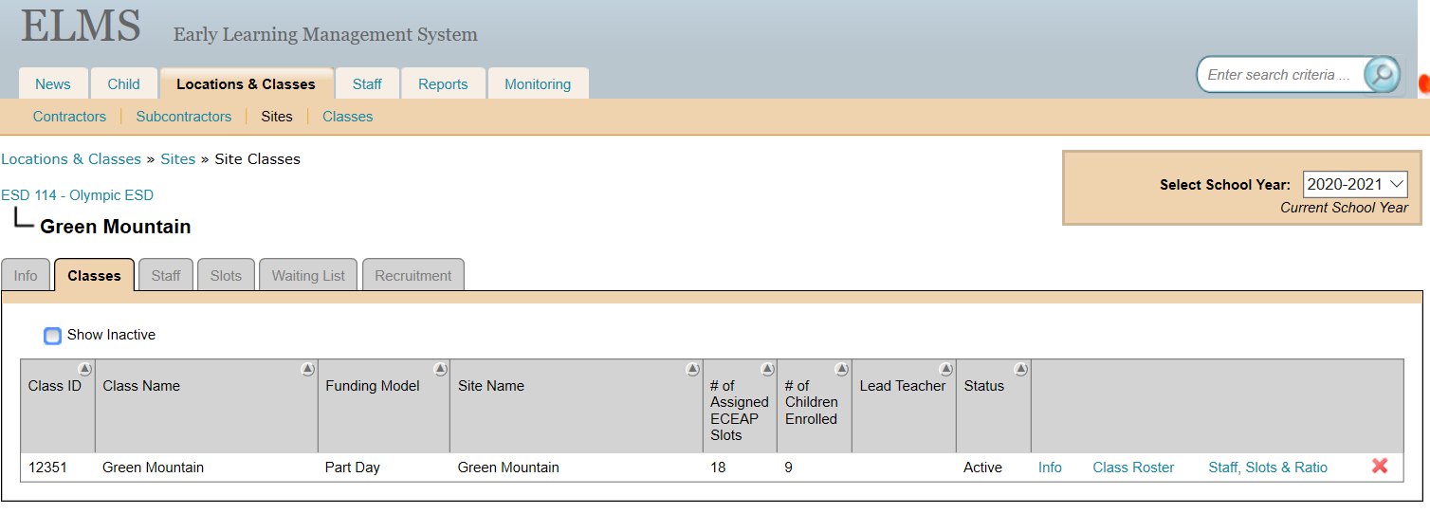

1. Find the child you are inputting for and click on “Child and Family Updates”. A pop up window will appear with the child’s information.
2. Click on “Child Development” tab

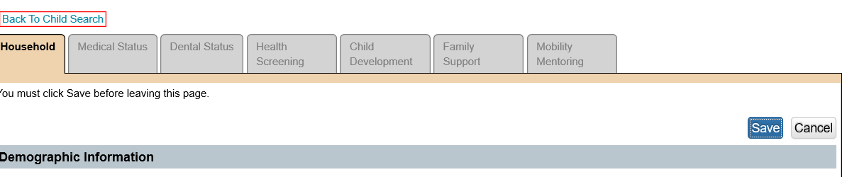

1. Click “Add Parent Teacher Conference

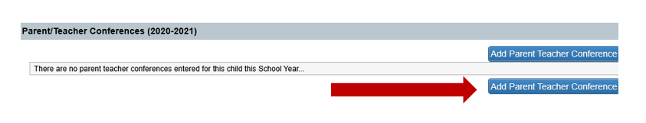

1. Fill out the form. Select the topics that were discussed during the conference, and give a description in the summary box of each topic selected.

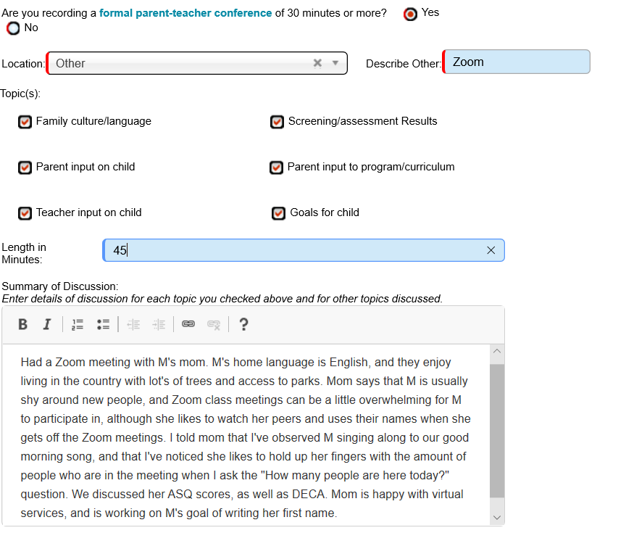**Note: This is an example of a fictional child.**

You can then copy and paste your ELMS conference notes into Child Plus so that you aren’t doing double data entry. ELMS gives you topics that you need to address, so it is suggested that you start in ELMS and copy and paste from there. If you start within CP, make sure your summary discussion topics are clearly defined in ELMS.

**Adding documentation in ELMS**

* ASQ (Developmental Screening)
* IEP
* Child Transportation
* Mental Health

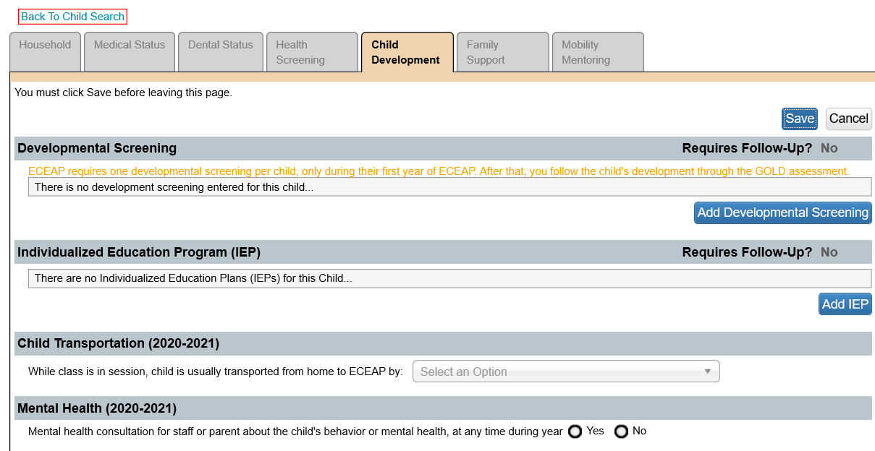

c

d

b

a

**Adding Screening documentation in ELMS**

a) To add the ASQ Screening, go to the Child Development tab.

1. Click on “Add Developmental Screening”

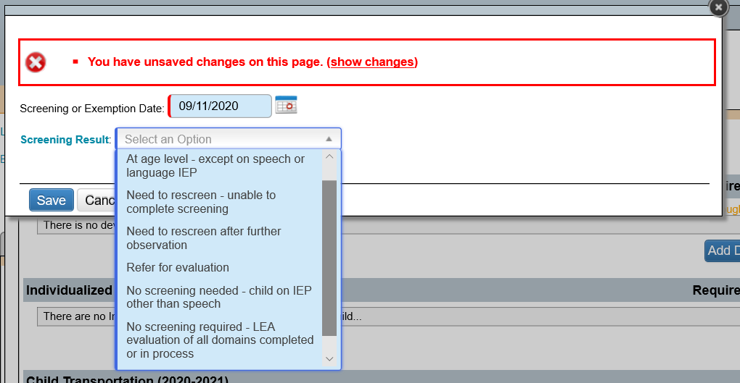

1. Enter in the date of the screening
2. Select the Screening Result from the pull down box
3. Click Save

**If “Need to rescreen- unable to complete screening” is selected:**

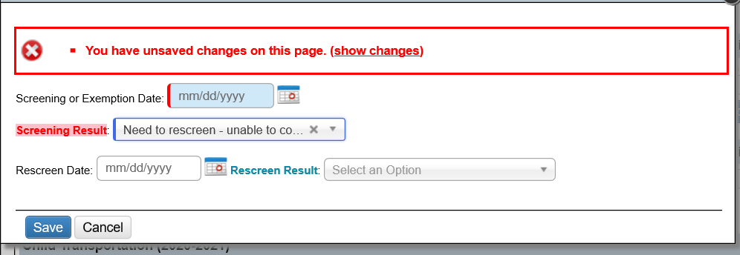

1. Add in the date that the screening was attempted
2. Enter in rescreen date
3. Pull down an option from the “Rescreen Result”
4. Choose an option
5. Save

**What if there is already, a Developmental Screening added:**

Once a developmental screening has been inputted we cannot change it.

Teachers create a note at the bottom of the Child Development section in ELMS (See picture below)

Input:

1. ASQ Developmental Screening completed and the results.

This would also apply for re-screens.

1. Save

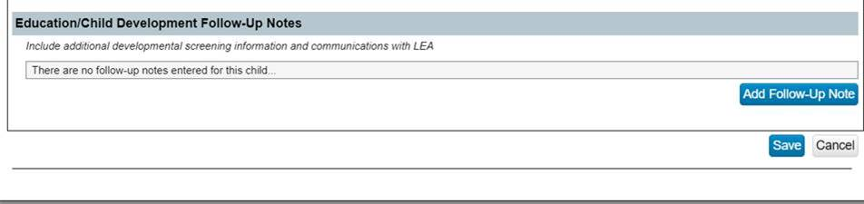**If a child needs a referral for evaluation:**

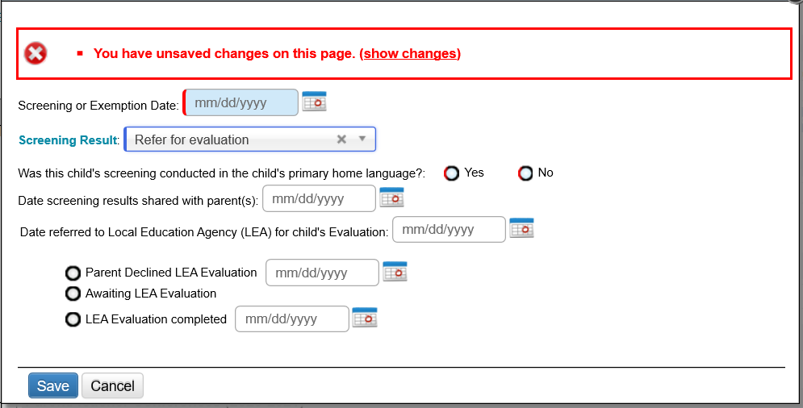

1. Fill out all the information
2. If a parent declines an evaluation then fill in the date and continue to fill out the corresponding information
3. When an evaluation is completed, make sure you enter the completion date into this section

**Adding an IEP into ELMS**

b) To add an IEP:

1. Click on “Add IEP”
2. This pop up will appear

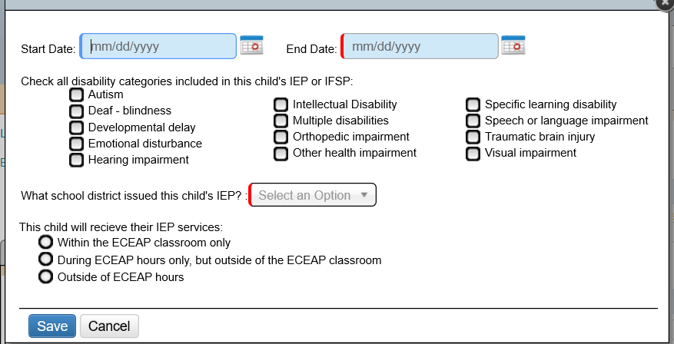

1. Enter the IEP Start and End dates
2. Select all that apply to the child’s IEP
3. Click “Save”

* Note: When updating an expired IEP they will need to enter the date the **DAY AFTER** the expired IEP ended. Example:  IEP expired 06/20/2020, regardless of what the current IEP says for start date, you will enter 06/21/2020 as start date in ELMS.

**Adding Child Transportation in ELMS**

c) Selecting Child Transportation

1. Click on “Select an Option”
2. From the pulldown screen, select the child’s mode of transportation

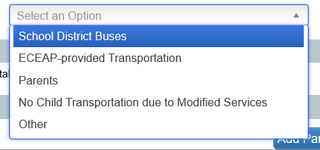

**Adding Mental Health in ELMS**

c) to select an option for Mental Health

1. Click “yes” or “no”