**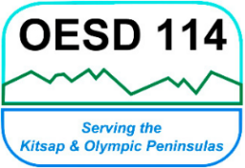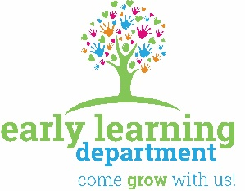*Olympic Educational Service District 114***

105 National Avenue North, Bremerton, Washington 98312

(360) 478-6887  1-800-201-1300  FAX (360) 405-5808

**INITIAL FAMILY CONTACT**

Participant’s Names (parent/guardian, and staff): Click or tap here to enter text.

Child’s Name: Click or tap here to enter text. Date: Click or tap to enter a date.

Do you have any special concerns about your child’s behavior or development? Click or tap here to enter text.

If so, what have you tried? Click or tap here to enter text.

What resources have you used? Click or tap here to enter text.

What support would you like from our program? Click or tap here to enter text.

GETTING TO KNOW

Click or tap here to enter text.

Something special about my family is: Click or tap here to enter text.

I learn best by: Click or tap here to enter text.

My family’s hopes and dreams for me are: Click or tap here to enter text.

Our favorite story to read together is: Click or tap here to enter text.

I really enjoy: Click or tap here to enter text.

Words that describe my personality are: Click or tap here to enter text.