*******Olympic Educational Service District 114*105 National Avenue North, Bremerton, Washington 98312**   
(360) 478-6887  1-800-201-1300  FAX (360) 405-5808

**Olympic ESD 114 Early Learning**

# EHS THREE-PRONG VISION & HEARING SCREENING

**I. Parent Interview Questions**

*Introduce these questions during first conversations to help alert you to look more carefully at a child’s vision and hearing. A health coordinator, parent educator, or other team member may conduct the interview.*

When was your baby’s last “well-baby” check-up? Click or tap to enter a date.

How would you describe (child’s name) birth? Click or tap here to enter text.

Did your baby have newborn hearing screening done in the hospital? Choose an item.

If YES, did he/she pass? Choose an item.

Has (child’s name) had any ear infections that you know of? Choose an item.

Has (child’s name) hearing or vision ever been tested by a Doctor? Choose an item.

If YES, when was that and who did the evaluation? Click or tap here to enter text.

What were the test results? Click or tap here to enter text.

Do you have any concerns about the way (child’s name) responds when you talk to him/her or how

(child’s name) is learning to talk? Click or tap here to enter text.

Does anyone in your family (immediate family or uncles, grandparents, etc.) have a hearing loss or visual impairment? Choose an item.

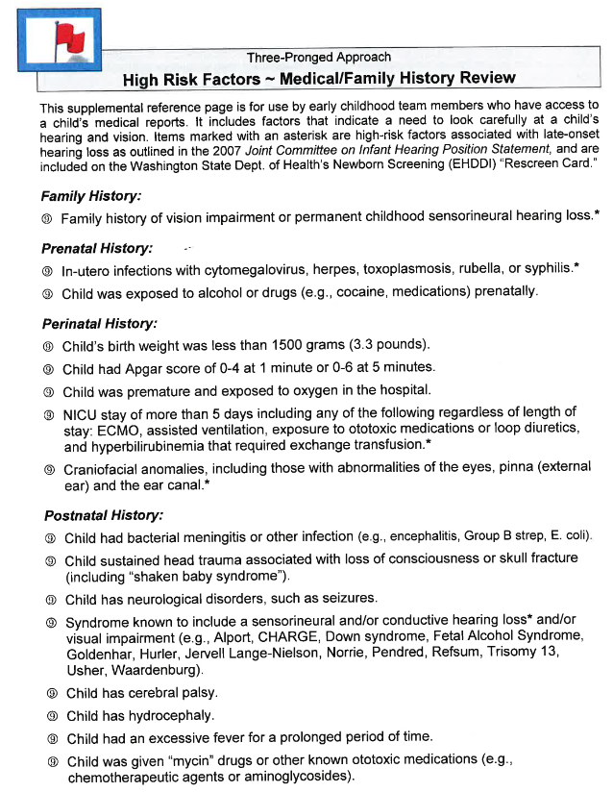

Child’s Name: Click or tap here to enter text. Date of Birth: Click or tap to enter a date.

Three-Pronged Approach  
**II. Developmental Skills Checklist**  
Related to Seeing and Hearing in Young Children

|  |  |  |  |  |
| --- | --- | --- | --- | --- |
| **SEEING**: Does the Child… | |  | **HEARING**: Does the Child… | |
| **BIRTH TO 3-MONTHS OLD**: | |  | **BIRTH TO 3-MONTHS OLD**: | |
| Look at your face? (briefly look by 1 month old) | Choose an item. |  | Startle or jump when there is a sudden loud sound? | Choose an item. |
| Imitate your smile? | Choose an item. |  | Stir or awaken from sleep, or cry when someone talks or makes a loud noise? | Choose an item. |
|  |  |  | Recognize and get comforted by a familiar voice? | Choose an item. |
|  |  |  |  |  |
| **BY 3- TO 6-MONTHS OLD:** | |  | **BY 3- TO 6-MONTHS OLD:** | |
| Smile at others? | Choose an item. |  | Turn his/her eyes to look for an interesting sound? | Choose an item. |
| Look at own hands? | Choose an item. |  | Respond to mother’s or other caregiver’s voice? | Choose an item. |
| Watch you as you enter or cross the room (from 6-feet away)? | Choose an item. |  | Turn eyes forward when his/her name is called? | Choose an item. |
| Reach out and bat at objects? | Choose an item. |  |  |  |
|  |  |  |  |  |
| **BY 6- TO 12-MONTHS OLD:** | |  | **BY 6- TO 12-MONTHS OLD:** | |
| Try to reach out and grasp at toys or other objects (6 mo.)? | Choose an item. |  | Turn toward an interesting sound or toward caregiver when his/her name is called from behind? | Choose an item. |
| Notice something small (like a raisin) when  12-inches from him/her  (6 mo.)? | Choose an item. |  | Search or look around when new sounds are present? | Choose an item. |
| Try to move toward an object that is at least  5-feet away (7 mo.)? | Choose an item. |  | Understand “no,” “mommy,” “bye-bye,” and similar common words? | Choose an item. |
| Pick-up or attempt to pick-up a cheerio, raisin, or lint (8 mo.)? | Choose an item. |  | Participate in vocal play with parents; experiment with different speech and non-speech sounds (9 mo.)? | Choose an item. |
| Imitate movements or actions of another person on a toy (9 mo.)? | Choose an item. |  | Babble in speech-like strings of singles syllables (like “da da da,” “ga ga”)?  (10 mo.) | Choose an item. |
| Stare at or try to grab your jewelry or glasses  (9 mo.)? | Choose an item. |  |  |  |
| Look for dropped toy (9 mo.)? | Choose an item. |  |  |  |
| React to facial expressions of others (like frowns, smiles, funny faces)? (10-12 mo.) | Choose an item. |  |  |  |
|  |  |  |  |  |
|  | |  |  | |
| **SEEING**: Does the Child… | |  | **HEARING**: Does the Child… | |
| **BY 12- TO 24- MONTHS OLD:** | |  | **BY 12- TO 24-MONTH OLD:** | |
| Show an interest in picture books (12 mo.)? | Choose an item. |  | Say one or more real, recognizable words (12 mo.)? | Choose an item. |
| Imitate scribbling (8-15 mo.)? | Choose an item. |  | Put words together (like mommy shoe, big boat)? (18 mo.) | Choose an item. |
| Reach into a container and pull objects out easily (12-18 mo.)? | Choose an item. |  | Use at least 50 words (24 mo.)? | Choose an item. |
|  |  |  |  |  |
| **BY 24- TO 36-MONTHS OLD:** | |  | **BY 24- TO 30-MONTHS OLD:** | |
| Imitate crayon stroke  (24-30 mo.)? | Choose an item. |  | Follow two requests combined? (like “get the ball and put it on the table) (24 mo.) | Choose an item. |
| Copy circle made by another person? | Choose an item. |  | Understand conversation easily? | Choose an item. |
| ***Color Identification:*** | |  | Hear when you call from another room? | Choose an item. |
| Match two items that are the same color (24-32 mo.)? | Choose an item. |  | Point to objects in a book when they are names? | Choose an item. |
| Sort items by color (36 mo.)? | Choose an item. |  | Say the following sounds clearly?  P, B, M, K, G, W, H, N, T, D | Choose an item. |
| Point to a color when asked  (36-42 mo.)? | Choose an item. |  | Use past tense verbs? (like walked, batted, fished, ran) | Choose an item. |
| ***Object to Picture Matching and Picture Identification:*** | |  | Name five pictures? | Choose an item. |
| Identify one picture of a familiar item (18-24 mo.)? | Choose an item. |  | Answer questions? | Choose an item. |
| Identify two or more pictures (24-32 mo.)? | Choose an item. |  | Use 1-2 prepositions? (like in, on, under) | Choose an item. |
| Match objects with pictures of objects (24-36 mo.)? | Choose an item. |  | Use sentences with real words instead of using nonsense-sounding “word strings?” | Choose an item. |
| ***Does Your Child Say…?*** | |  |  | |
| “My Eyes are Itchy” | Choose an item. |  | **BY 30- TO 36- MONTHS OLD:** | |
| “My Eyes Hurt” | Choose an item. |  | Hear TV or radio at same loudness level as other family members? | Choose an item. |
| “Things Look Blurry” | Choose an item. |  | Notice sounds? (like dog barking, phone ringing) | Choose an item. |
| The “seeing” developmental skills on this page are from Dr. Tanni Anthony’s doctoral work (2005) on visual skills for *Transdisciplinary Play-Based Assessment*. | |  | Can make most sounds correctly at start of words? (like says the “th” sound in “think”, but says “baff” instead of “bath”) | Choose an item. |
|  |  |  | Use 1-2 prepositions? (like in, on, under) | Choose an item. |
| The “hearing” developmental skills are adapted from the *Hawaii Early Learning Profile Language Scale*. | |  | Use plurals? (like dogs, cookies) | Choose an item. |
|  |  |  | Refer to self, using a pronoun? (I, me) | Choose an item. |
|  |  |  | Use 200+ words? (300+ by age 3) | Choose an item. |
|  |  |  | Give full name when asked? | Choose an item. |
|  |  |  | Help tell stories? | Choose an item. |
|  |  |  | **HEARING (30-36 MO.) CONT’D**: Does the Child… | |
|  |  |  | Ask questions beginning with “what,” “where,” or “when”? | Choose an item. |
|  |  |  | Use speech that can be understood by others most of the time? | Choose an item. |
|  |  |  |  |  |
| Initial Screening Date: | Click or tap to enter a date. |  |  |  |
| Name of Screener: Click or tap here to enter text. | |  |  |  |
| Annual Screening Dates: |  |  |  |  |
| 1 | Click or tap to enter a date. |  |  |  |
| 2 | Click or tap to enter a date. |  |  |  |
| 3 | Click or tap to enter a date. |  |  |  |
|  |  |  |  |  |
|  |  |  |  |  |
|  |  |  |  |  |
|  |  |  |  |  |

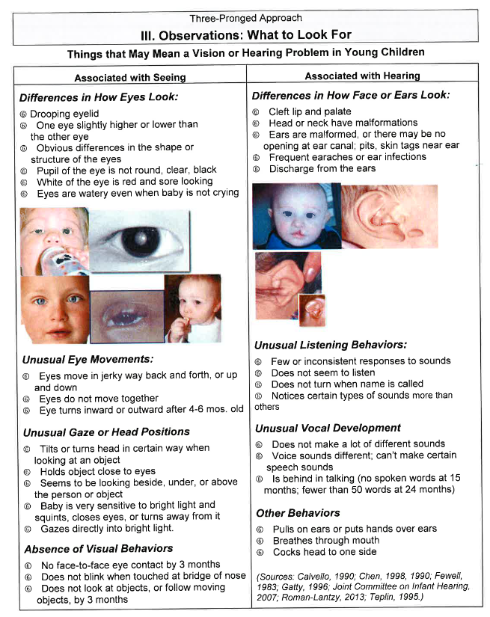

Three-Pronged Approach – EARLY HEAD START

**Summary Form: Addressing Vision and Hearing Concerns**

Child’s Name: Click or tap here to enter text. Birthdate: Click or tap to enter a date.

Parent/Caregiver: Click or tap here to enter text. Phone: Click or tap here to enter text.

FRC/Service Provider: Click or tap here to enter text. Primary Care Physician: Click or tap here to enter text.

**I – PARENT/CAREGIVER INTERVIEW**

1. The parent/caregiver has concerns about the child’s vision and/or hearing at this time: Choose an item.   
   If YES, the concern is related to the child’s: Choose an item.
2. Describe the concerns regarding the child’s hearing or vision skills development:  
   Click or tap here to enter text.

**FAMILY & MEDICAL HISTORY REVIEW** – Please note any factors in child’s family and/or medical history that might indicate higher risk for hearing/vision impairments: Click or tap here to enter text.

**II – DEVELOPMENTAL SKILLS CHECKLIST** (Describe any skills of concern for child’s age):

1. Vision Related: Click or tap here to enter text.
2. Hearing Related: Click or tap here to enter text.

**III – OBSERVATIONS** (Describe observations that might indicate higher risk for vision/hearing problems):  
Click or tap here to enter text.

Results of InfantSEE evaluation (if applicable): Choose an item.

Comments: Click or tap here to enter text.

Results of OAE Hearing Screening (if applicable): Choose an item.

Comments: Click or tap here to enter text.

SUMMARY:

We *have no concerns* regarding the child’s vision or hearing at this time, based on parent interview with family/medical history review, developmental skills related to vision or hearing, and our joint observations.

We *have identified* high-risk factors, signs, and/or observations as noted above for: Choose an item.

Note: These concerns and a follow-up plan will be addressed in the Family Partnership Agreement. Action taken and results will be discussed at the six-month review.

Follow-up option recommended:

Referral to Primary Care Physician (PCP) and then, if appropriate, to a pediatric ophthalmologist or pediatric audiologist.

FAMILY/GUARDIANS ACCEPTS

*By selecting the “FAMILY ACCEPTS” button, you are verifying that you have spoken directly to this family regarding this Three-Pronged Early Head Start Vision and Hearing Screening, and the family has agreed to receive recommended action contained within and to share information.*

Family Name (first and last): Click or tap here to enter text. Date: Click or tap to enter a date.

Staff Name: (first and last): Click or tap here to enter text.