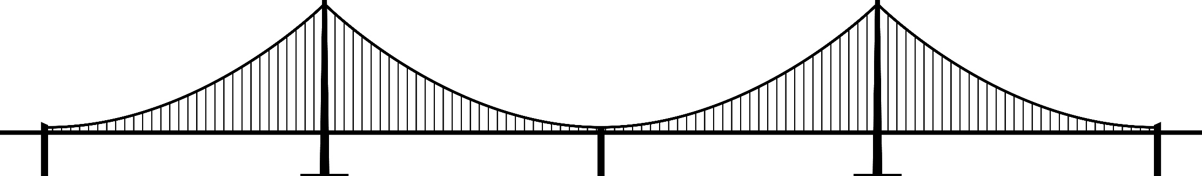 n

considering big picture Decision making

Future Oriented Decision Making

**Household 1: <Child Name>**

|  |  |  |  |  |  |  |  |
| --- | --- | --- | --- | --- | --- | --- | --- |
| **Family Stability** | | **Well-Being** | | **Financial Management** | | **Education & Training** | **Employment & Career Management** |
| **Housing** | **Family & Dependents** | **Physical & Mental Health** | **Personal & Professional Networks** | **Debts** | **Savings** | **Educational Attainment** | **Earnings Levels** |
| Click or tap here to enter text. | Click or tap here to enter text. | Click or tap here to enter text. | Click or tap here to enter text. | Click or tap here to enter text. | Click or tap here to enter text. | Click or tap here to enter text. | Click or tap here to enter text. |
| No housing subsidy, housing costs less than 1/3 household gross pay. | Fully able to engage in work, school and family life; children or family needs met. | Fully able to engage in work, school and family life; health and mental health needs met. | Can always rely on networks to provide useful advice, guidance and support; advocates for others. | No debt other than mortgage, education and/or car loans. Current in all debt. | Savings of greater than three months’ expenses. | Bachelor’s degree or higher complete. | Job with earnings equal to or greater than Washington living wage. |
| No housing subsidy, housing costs exceed 1/3 household gross pay. | Mostly able to engage in work, school and family life; children or family needs nearly met. | Mostly able to engage in work, school and family life; health and mental health needs nearly met. | Can often rely on networks to provide useful advice, guidance and support. | Current in all debts and paying more than minimum balances on one or more debts. | Savings of more than two months’ expenses but less than three months’ expenses. | Associate degree or higher complete. | Job with earnings of 66-99% of Washington living wage |
| Partial housing subsidy. | Somewhat able to engage in work, school and family life because of children or family needs. | Somewhat able to engage in work, school and family life because of health and mental health needs. | Can sometimes rely on networks to provide useful advice, guidance and support. | Paying minimum balances on all debts. | Savings of at least one month and up to two months’ expenses. | Postsecondary job training or professional certificate complete. | Job with earnings of 33-65% of Washington living wage |
| Full housing subsidy, permanent housing. | Barely able to engage in work, school and family life because of children or family needs. | Barely able to engage in work, school and family life because of health and mental health needs. | Can rarely rely on networks to provide useful advice, guidance and support. | Behind in payment of one or more debts. | Savings of less than one month’s expenses. | GED, high school or High School 21+ complete. | Job with earnings less than 33% of Washington living wage |
| Homeless as defined by [McKinney-Vento](https://www.k12.wa.us/student-success/access-opportunity-education/homeless-education). | Not able to engage in work, school and family life because of children or family needs. | Not able to engage in work, school and family life because of health and mental health needs. | Can never rely on networks to provide useful advice, guidance and support. | Not addressing debts. | No savings yet. | Less than GED or high school diploma or taking GED prep or high school completion classes. | No wage earnings currently.  *\*see* [*WA Self-Sufficiency Calculator*](http://www.thecalculator.org/) *for specific calculations based on family size, county and other factors.* |
|

Name: Click or tap here to enter text. Date: Click or tap here to enter text.