Investigation/ Part | Focus Question | Writing Support | CCSS-ELA  NGSS
Investigation 1: Schoolyard Models  Part 1: Schoolyard Models | What is a model? What are some examples of models? | (Classroom preparations ahead of teaching the kit):  - You will need to group students so they can work and talk in pairs  - Designate an area where students can gather as a class and you can model the creation of data tables, and other written records used in discussions.  - Establish and display two word banks: one for the terms that are introduced during the instructional sequence (Tier 2 and 3 Vocabulary see CCSS-ELA Appendix A pg.32-33) and the other for displaying focus questions.  - Create sentence strips of the focus questions that frame each lesson or series of lessons.  Pre- Instruction:  - Have the students answer the focus question “what is a model? in their science notebooks and then have a discussion to reveal their thinking. At this point don’t answer the question but allow the conversation to evolve and provide more information as the lesson unfolds.  - Provide the following writing frame as needed:  A model is ____________________, and an example of this would be _____________________.  - Lead a classroom discussion about the word model and elicit some examples the group.  - Note: the word model is used in everyday vernacular and therefore students may have an understanding of this word that is partially correct. In science a model can be more then just a small version of an object as it can be a mental representation or even a drawing. In addition to this a model can be a process rather than just a representation of an object. An example of this is a model of a stream eroding through a section of rock or soil which is a model of a geological process.  Word Bank:  Model  Boundary  Structure | 4-ESS2-2  Analyze and interpret data from maps to describe patterns of Earth’s features.  http://www.nextgenscience.org/4ess2-earth-systems  CCSS.ELA-Literacy.W.5.2b  Develop the topic with facts, definitions, concrete details, quotations, or other information and examples related to the topic.
Investigation 1: Schoolyard Models  Part 2: View from Above | How is a map like a model?  How is a map different from a model? | Pre-instruction:  - Review with the students the definition of the word model, and have them give specific examples.  - Introduce the focus question and allow students to discuss in pairs and share with the group.  Post-instruction:  Shared writing mini-lesson (writing about observations):  - Utilizing a Box and T-Chart graphic organizer lead the students in comparing and contrasting a model and a map.  - What is similar in the two representations?  - What is different in the two?  Note: Depending on the readiness of the group you may have them complete this on their own or your can model the compare and contrast activity.  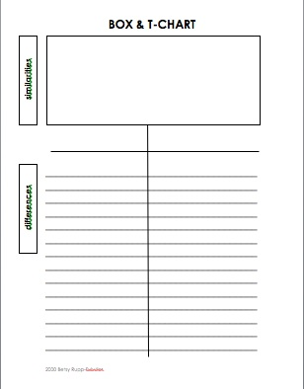  - Lead the group through creating a writing sample to complete an answer to the FOSS Response Sheet – Schoolyard Models.  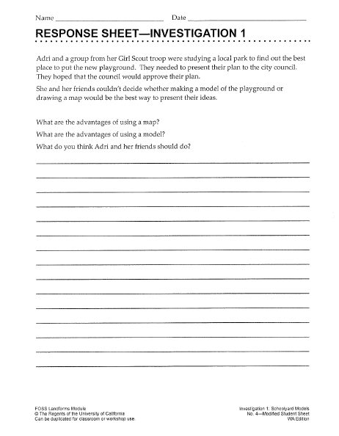  - Scaffold the students by using the completed graphic organizer encouraging the use of the vocabulary with special emphasis on linking ideas through the use words, phrases, and clauses.  - Have students speak to one another answering the question and using the vocabulary ahead of actually writing the answers.  “The advantages of using a map are _________________ compared to a model.”  “The advantages of using a model are ________________ compared to a map.”  Word Bank:  Map  Cartographer  Grid | 4-ESS2-2  Analyze and interpret data from maps to describe patterns of Earth’s features.  http://www.nextgenscience.org/4ess2-earth-systems  CCSS.ELA-Literacy.W.5.2b  Develop the topic with facts, definitions, concrete details, quotations, or other information and examples related to the topic.
Investigation 2: Stream Tables Part 1-. Erosion and Part 2 Deposition | How are erosion and weathering different? | Pre-instruction:  - Begin lesson and topic introduction by having the students complete the FOSS Response Sheet for Investigation 2- Stream Tables (Individual Writing)  - Following gathering their initial ideas have the students form groups of four and discuss their individual ideas and write a group response on a white board to share with the class. (Speak and Write)  - Have the groups share their thinking with the class (Classroom Discussion).  - Introduce Claims-Evidence-Reasoning Framework Utilizing the groups sample responses to this FOSS Response Sheet-Stream Tables complete a mini lesson on the components of a complete scientific explanation.  - Introduce the CER framework as model for creating scientific explanations.* This framework should be introduced in a separate lesson identifying the various parts of the framework. Make a public display of the components of a scientific explanation so students can have a visual reminder.  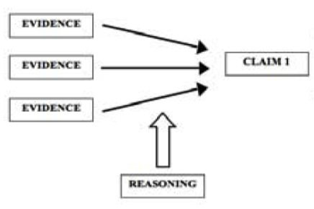  This framework provides a graphical representation of the various elements of a complete scientific explanation- claim, evidence, and supportive reasoning. Support can be offered through a visual representation and explanation of the components of a complete explanation through the use of the CER framework below.  - Have students self evaluate their own explanations identifying the claim (circle), supporting evidence (underline), and scientific reasoning double underline.  *CER Framework Explanation:  http://alwaysformative.blogspot.com/2012/04/claim-evidence-reasoning.html  Post Instruction Writing mini-lesson:  - Following completion of the second part of this investigation re-visit the scientific explanations that the students created both the group and the individual work.  - Identify the Claim-Evidence- and Reasoning within the explanations.  - Model the creation of a complete scientific explanation using the CER framework as a guide.  - Scaffold students ability to re-write their explanations using the CER framework.  Instructional Note: During the investigation the students will be making observations and gathering evidence to support their scientific conclusions for this explanation. You will need to find a way to capture their observations and make their thinking visible in displays for reference later during the writing activity. Consider the use of the “evidence buckets” strategy referenced below or other strategies listed for making thinking visible.  http://tools4teachingscience.org/tools/public/buckets.html  Word Bank:  Drainage bank  Erosion  Landform  Canyon  Delta  Plateau  Deposition  Sediments  Basin  Channel  Meander | 4-ESS2-1  Make observations and/or measurements to provide evidence of the effects of weathering or the rate of erosion by water, ice, wind or vegetation.  http://www.nextgenscience.org/4ess2-earth-systems  CCSS.ELA-Literacy.W.5.2e  Provide a concluding statement or section related to the information or exploration presented.
Investigation 3: Go With The Flow.  Part 1 Slope and Part 2 Flood | How does the slope of the stream table affect erosion and deposition? | Pre-instruction (introduction of setting up the investigation (investigative question, data table, procedures) provides template and scaffolds the second part of this investigation):  - Discuss slope and introduce the investigative question within the context of the Grand Canyon or another local context if applicable.  - Introduce the investigative question (focus question) written and displayed publically.  - Have the students write a response to the focus question (investigative question) in their science notebooks.  - Provide scaffold writing frame as necessary:  - The greater the slope of the stream table the ______________ the erosion and deposition because __________________.  - Identify the manipulated variable (slope of stream table) and the responding variable (erosion and deposition activity-important events).  - Identify the controlled variables (amount and rate of water applied, sand substrate used, similar amount of packing of sand materials)  - Model the creation of the data table that the students will use to collect data from the various conditions. You can opt to handout the Stream-Table Data Sheet  - Model collection of class data into the data table (public representation).  Post-lesson investigation (writing mini-lesson):  - Using their observations and collected data have the students write a scientific conclusion for the experimental question.  - Scaffold the use of the CER framework as necessary.  - Remind the students of the CER framework and that all good scientific explanations consist of a claim-evidence- and reasoning as discussed in the previous investigation.  - You might consider having students verbally exchange ideas about the investigative question in pairs ahead of writing a scientific explanation.  - .  The stream table with the greatest slope caused ___________because ___________________. I think this because___________ and ___________________.  The reason this happened is because_____________.  Word Bank:  Slope  Alluvial Fan  Flood  Flash Flood  Manipulated variable  Responding variable  Control variable  Procedures | CCSS-ELA W.5.2e  Provide a concluding statement or section related to the information or explanation presented.  http://www.corestandards.org/ELA-Literacy/W/5/2/e  4-ESS2-1  Make observations and/or measurements to provide evidence of the effects of weathering or the rate of erosion by water, ice, wind or vegetation.  http://www.nextgenscience.org/4ess2-earth-systems
Investigation 3: Designing an Investigation | What type of human made structures can prevent erosion and protect homes from damage? | Pre-instruction:  - Review the essential elements of a controlled investigation by reviewing the test and results from Investigation 3 Part 2: Slope and Stream Erosion and Deposition.  - Why would someone want to build a home next to or near a river?  - What kinds of problems might someone have that lives near a river?  - Pose the following design challenge:  - What types of human made structures can protect homes that are built near a river?  - Brainstorm a list of human made structures that can provide protection from river erosion (possible solutions).  - Establish an agreed upon procedure for testing solutions, data table for recording data, along with variables (manipulated, responding, and controlled)  Note: writing a scientific explanation should be scaffolded based on the previous experience with the CER frameworks from above.  Post Instruction:  - Utilize the CER framework to have the students write a scientific explanation answering the investigative question. Note: depending on the group you may need to model writing this explanation in front of the class.  - Follow this intentional format for leading students in this writing exercise:  - Provide a written “frame” or conversation starter to engage student discourse (partner talk)  - Teacher speaks reading the investigative question and frame.  - Students speak to a partner to share your explanation using “frame”  - Teacher models writing an explanation using the frame identifying the claim, evidence, and reasoning  - Students write a scientific explanation using the frame  The best structures for protecting homes on a river are/is ____________________ based my observations. My evidence for this is _________________________. | CCSS-ELA W.5.2e  Provide a concluding statement or section related to the information or explanation presented.  http://www.corestandards.org/ELA-Literacy/W/5/2/e  3-5-ETS 1-3.  Plan and carry out fair tests which variables are controlled and failure points are considered to identify aspects of a model or prototype that can be improved.  http://www.nextgenscience.org/3-5ets1-engineering-design
Investigation 4: Build a Mountain  Part 1: Making a Topographic Map | How can we make a map that depicts different elevations on a mountain? | Pre-instruction:  - Introduce the focus question for the activity  - Show an image or sample of a topographic map and ask students to make observations of the map, allow time to record observations in their science notebooks:  - Provide relevant modeling and speaking as a small group and as a class while making observations of a topographical map.  - I observed that……..  Post Instruction:  - Identify the relevant vocabulary introduced in the lesson and record in science notebooks  Word Bank:  Base  Contour line  Contour interval  Elevation  Peak  Sea level  Topographic map | 4-ESS2-2  Analyze and interpret data from maps to describe patterns of Earth’s features.  http://www.nextgenscience.org/4es-earths-systems-processes-shape-earth
Investigation 4: Build a Mountain  Part 2-3: Drawing a Profile  FOSS Creek Map | How can you draw a profile of a mountain from a topographical map?  What information can we get from a topographical map? | Follow same pattern as noted above with emphasis on Word Bank vocabulary.  Word Bank:  Profile  Benchmark  Intermittent stream  Perennial stream | 4-ESS2-2  Analyze and interpret data from maps to describe patterns of Earth’s features.  http://www.nextgenscience.org/4es-earths-systems-processes-shape-earth
Investigation 5: Bird’s Eye View | How do you read a topographic map? | Note: writing lesson begins in Part 2 Mt. Shasta Aerial Photos. The writing emphasis here is on comparing and contrasting the (noting the similarities and differences) between an aerial photo and a topographical map of the same areas. The students will make observations and compare the two visual representations of Mt. Shasta with the goal of writing a response to the FOSS Response Sheet: Bird’s Eye View.  Part 2:  Pre-Instruction:  - Use the Box and T-Chart below to discuss the similarities and differences between the aerial photograph and the topographical view of Mt. Shasta. This can be done following the initial observations of the two using the model (foam blocks) of Mt. Shasta to orient them to the features.  Post-Instruction:  - Complete the graphical organizer and review similarities and differences between the two with the whole class.  - Use the completed graphical organizer as a scaffold to writing a response to the FOSS- Response Sheet – Bird’s Eye View.  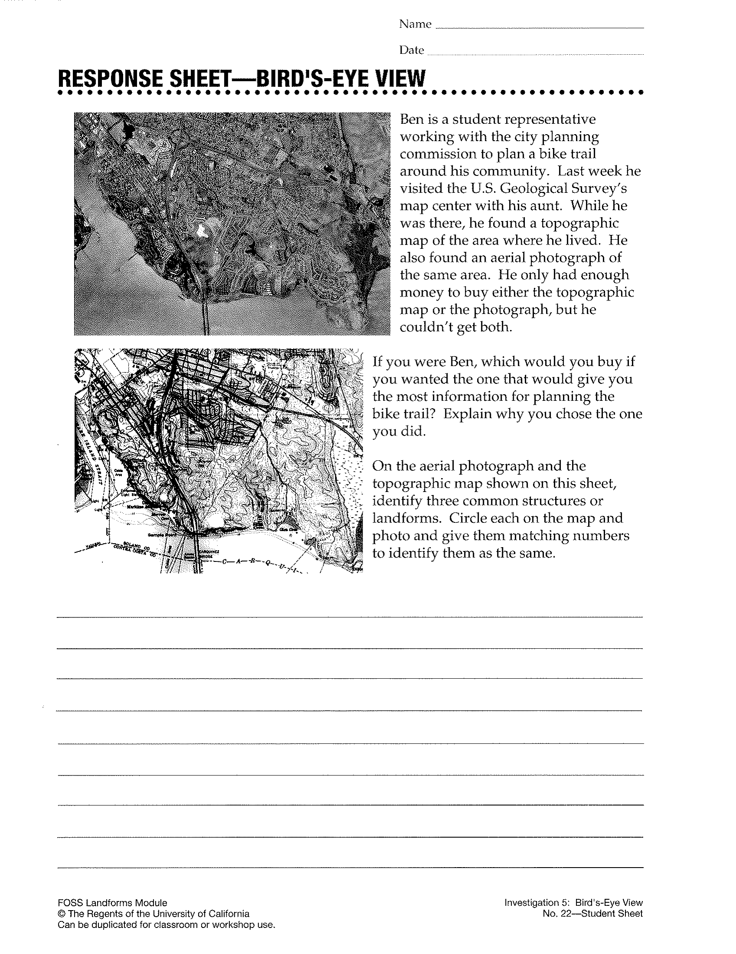  - Scaffold as appropriate using the Compare and Contrast Writing Frame:  Start with how things are the same or similar:  The ___________________ and the __________________ are similar because they both ____________________. In addition, they _________________.  Add more detail as needed.  Explain how they are different. You can compare the same property or characteristic in the same sentence. Use and, but, or whereas to set up the contrast.  The ______________________ and the ________________________ are different because the _______________________, but the ______________. Also, the _______________________, ________________, whereas ________________________. | CCSS.ELA-Literacy.W.5.1  Write an opinion piece on topics or texts, supporting a point of view with reasons and information.  4-ESS2-2  Analyze and interpret data from maps to describe patterns of Earth’s features.  http://www.nextgenscience.org/4es-earths-systems-processes-shape-earth

Resources cited:

Krajcik, J., & McNeil, K. (2012). Supporting grade 5-8 students in constructing explanations in science: The claim, evidence, and reasoning framework for talk and writing. (1st ed.). New York: Pearson. Retrieved from http://www.amazon.com/Supporting-Students-Constructing-Explanations-Science/dp/0137043457

Rupp-Fulwiler, B. (2011). Science in writing in action. (1 ed., Vol. 1). Portsmouth: Heinemann. Retrieved from http://www.heinemann.com/products/E04211.aspx

