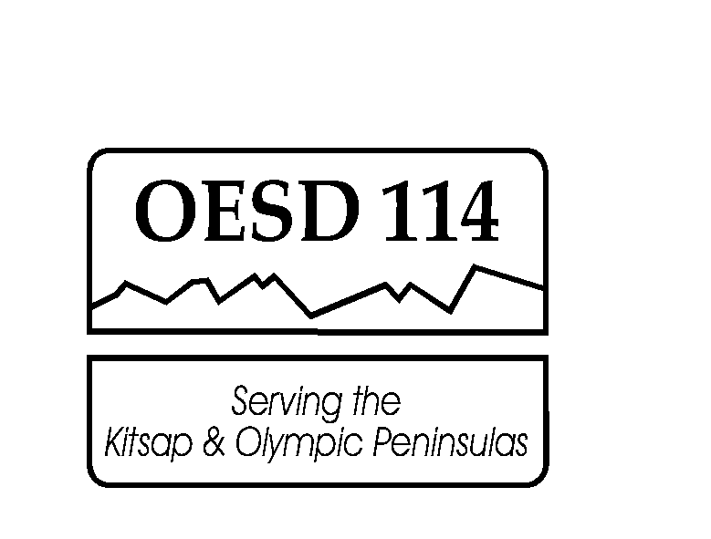
Olympic Educational Service District 114
105 National Avenue North ● Bremerton, Washington 98312
(360) 405-5832 ● FAX (360) 478-6869

Instructional Resources

2019-2020 Knowledge Bowl School Registration Form

SCHOOL: ______________________________________________________

COACH NAME(S): _______________________________________ ____________

READER/JUDGE #1 (1-3 teams): ____________________________________ ____

*READER/JUDGE #2 (4-6 teams): __________________________________________

Please indicate the number of teams your school is registering for the 2019-2020 year ($372 per team includes 3 competitions):

1 2 3 4* 5* 6*

Will your school have additional teams available for individual competitions if needed? (Extra teams to be billed at $124 per team.)

YES NO

Will your school have additional Reader/Judges available for individual competitions if needed?

YES NO

Thanks!
Sarah Freitas

